**Introduction**

Effective transportation management plays a vital role in ensuring seamless operations and convenience within a university environment. The Smart Transport Management System introduces an AI-driven approach to modernize and enhance transportation services for students and staff. This innovative application is designed to automate key processes, optimize resource utilization, and deliver a cost-efficient and user-friendly transportation experience.

The system empowers university transport administrators to manage essential details, such as vehicle assignments, route planning, and driver scheduling, with ease. Leveraging AI, the application analyzes real-time and historical traffic data to recommend optimal routes that minimize travel time and fuel consumption, thereby boosting overall efficiency.

For students, the system offers an intuitive interface that allows them to register, and specify pick-up and drop-off preferences. It dynamically assigns vehicles based on availability and provides real-time trip notifications. To maintain scheduling accuracy, users are required to communicate any changes in their travel plans at least three hours in advance. Additionally, the system keeps comprehensive records of transport details, trip expenses, and fee payments. To promote accountability, students with overdue payments are temporarily deactivated until dues are cleared, ensuring uninterrupted service only for compliant users.

The application further enhances operational workflows by enabling drivers to update pick-up and drop-off statuses during trips, with all changes synchronized in real time for administrators and users. payment options and receipt uploads simplify the fee submission process, adding convenience for users.

By integrating advanced AI functionalities, the Smart Transport Management System delivers a scalable and efficient solution tailored to the complex requirements of university transportation. This project seeks to streamline operations, minimize costs, and enhance user satisfaction by providing timely, reliable, and efficient transport services.

## 

## 

## 

## 

## 

## 

## Literature Review

The development of a Smart Transport Management System (STMS) for university transportation aligns with various research efforts and real-world implementations. Although no existing work precisely matches the scope and objectives of our project, several studies have examined related areas, such as AI-based route optimization, automated attendance systems, and real-time tracking in transport management.

1. **AI in Ride-Hailing and Transport Optimization:**  
   Applications like Uber, Lyft, and Careem utilize AI to match drivers with passengers, optimize routes, and calculate costs dynamically. These systems demonstrate the potential of AI in transport management.  
   **Comparison with our project:** While these platforms prioritize passenger convenience and on-demand services, our STMS is specifically tailored for university transportation with features like monthly fee management and route optimization for students and staff.  
   **References:**

* [Uber](https://www.uber.com/fi/en/)
* [Lyft](https://www.lyft.com/)
* [Careem](https://www.careem.com/)
* [InDrive](https://indrive.com/)

1. **Machine Learning in Public Transport Systems:**  
   The study "An Intelligent Machine Learning-Based Real-Time Public Transport System" explores AI-driven solutions to provide real-time updates on bus statuses and assist managers with data-driven decisions regarding routes and ridership. This system incorporates neural networks for ridership predictions, offering insights into optimizing resource allocation.  
   **Reference:**

* [Springer Link](https://link.springer.com/chapter/10.1007/978-3-030-58817-5_47?utm_source=chatgpt.com)

1. **AI Applications in Transportation:**  
   The paper "Artificial Intelligence for Smart Transportation" highlights how AI can revolutionize public transit systems by improving operational efficiency and decision-making. It discusses key methodologies like data integration, problem-solving techniques, and decision-making frameworks applicable to transportation.  
   **Reference:**

* [arXiv](https://arxiv.org/abs/2308.07457?utm_source=chatgpt.com)

1. **Student Transportation Solutions:**  
   EduTransport is a mobile application designed for managing school and college transportation. It automates attendance tracking and provides real-time vehicle location updates, focusing on student safety and convenience. However, it lacks AI-driven features for predictive analysis or cost optimization.  
   **Reference:**

* [EduTransport Blog](https://edutransport.blog.com/)

1. **Automated Transportation Management in Educational Institutions:**  
   The research titled "Automated Transport Management System: Route Optimization and Attendance Tracking for Institutions" introduces a comprehensive platform that integrates GPS for live tracking and barcode-based attendance logging. It emphasizes reducing manual errors and improving the reliability of student transportation systems, aligning with several goals of our project.  
   **Reference:**

* [IRJAEH Journal](https://irjaeh.com/index.php/journal/article/view/454?utm_source=chatgpt.com)

By analyzing these studies, our project builds on existing innovations while addressing the unique needs of a university transport system through AI-driven automation, resource optimization, and enhanced user experience.

## Design and Schematics

## ERD Component Diagram

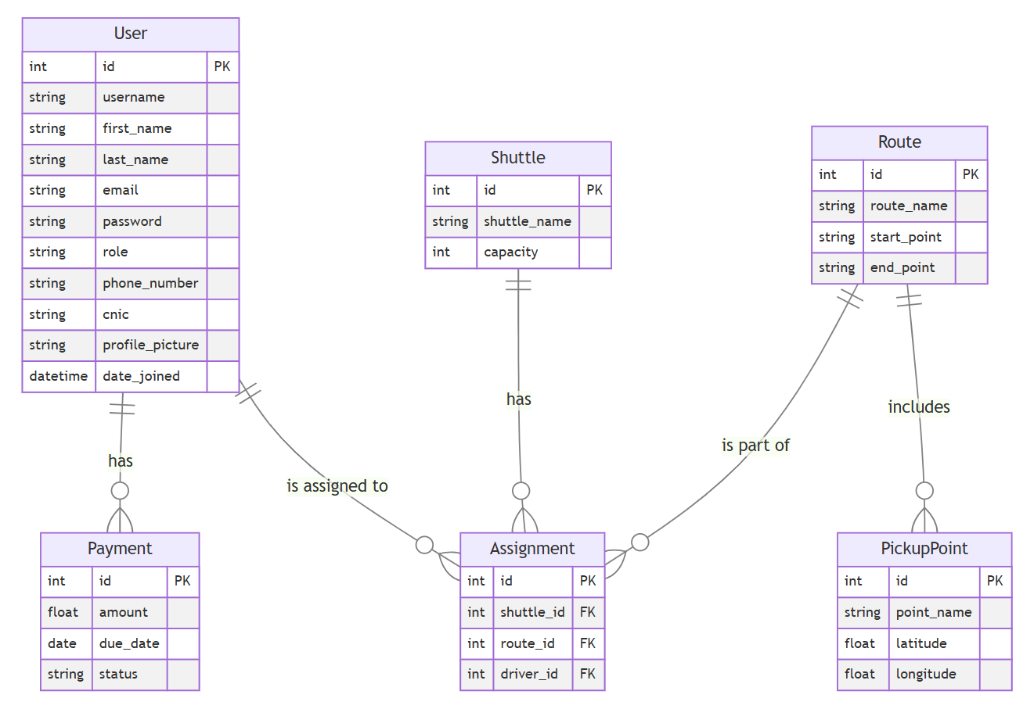

## 

## 

## 

## Deployment Diagram

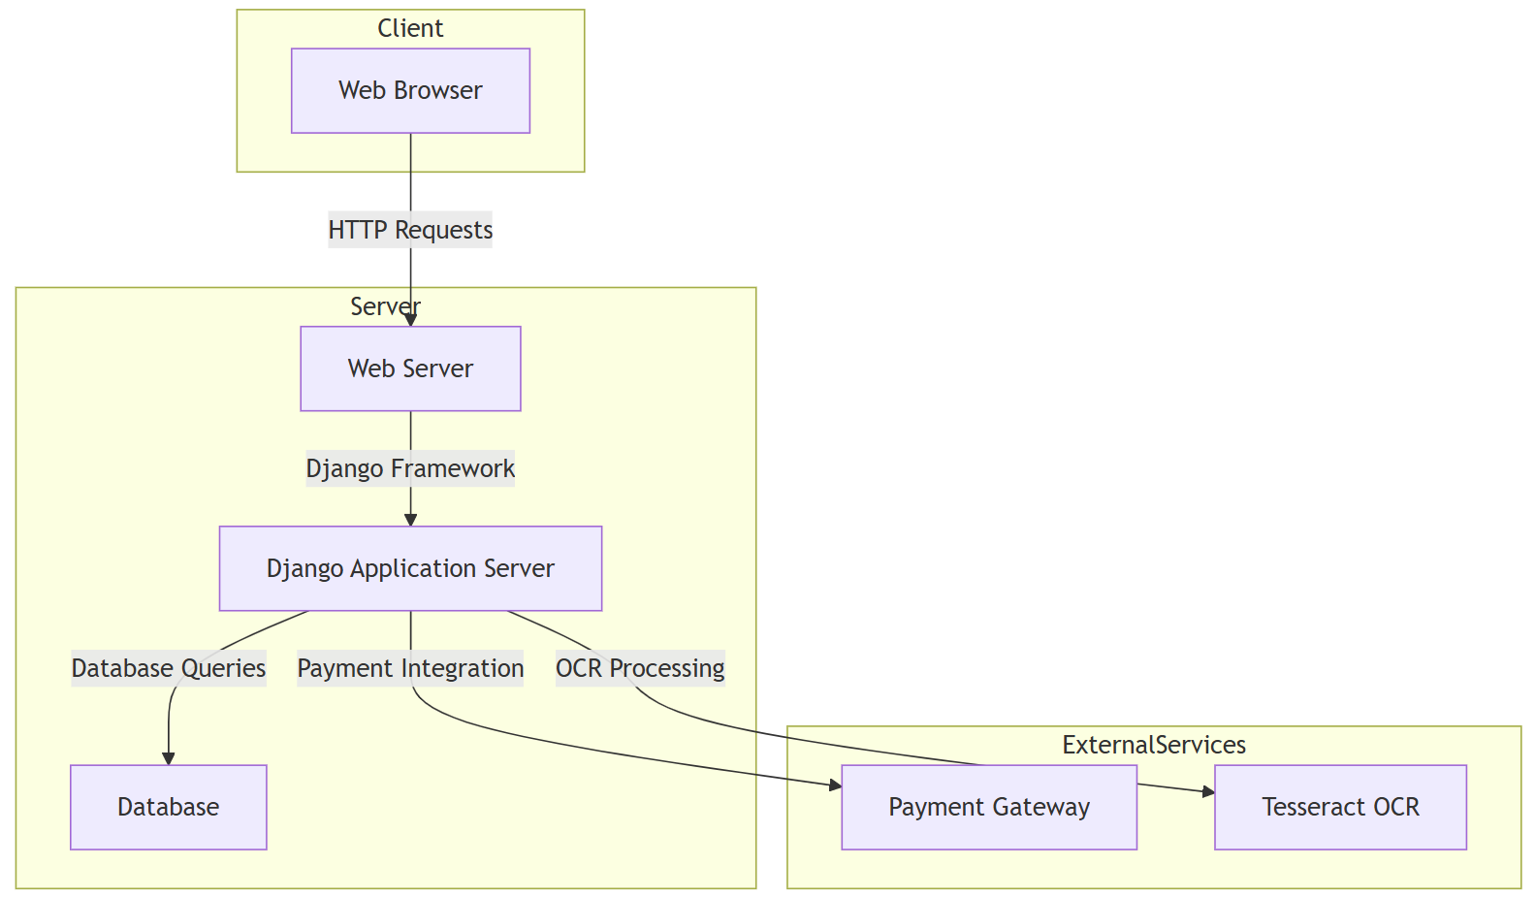

## 

## 

## Class Diagram

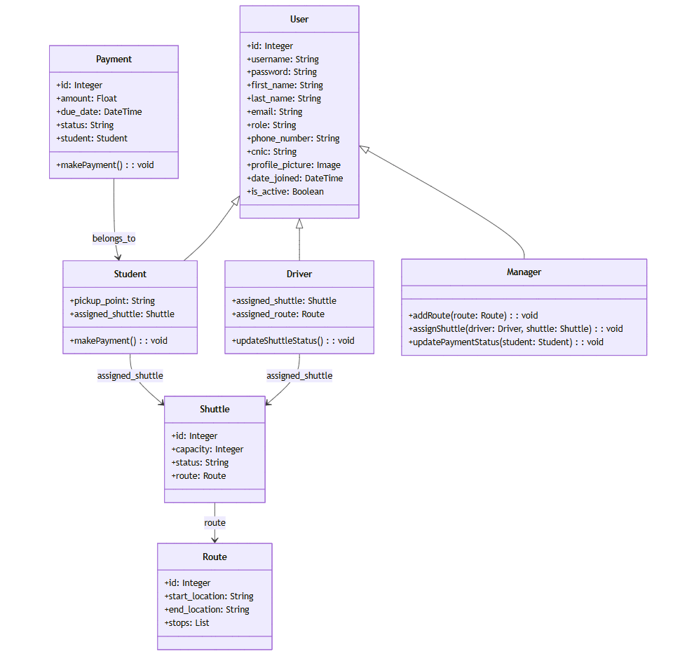

## 

## Activity Diagram

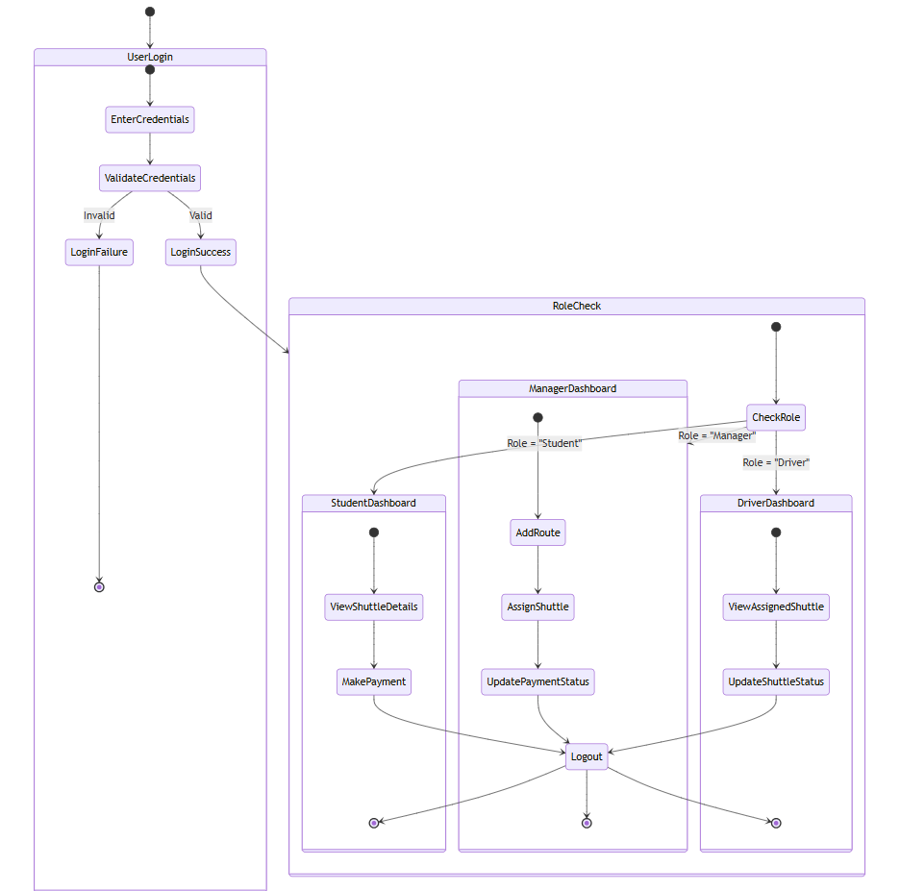

## Use Case Diagram

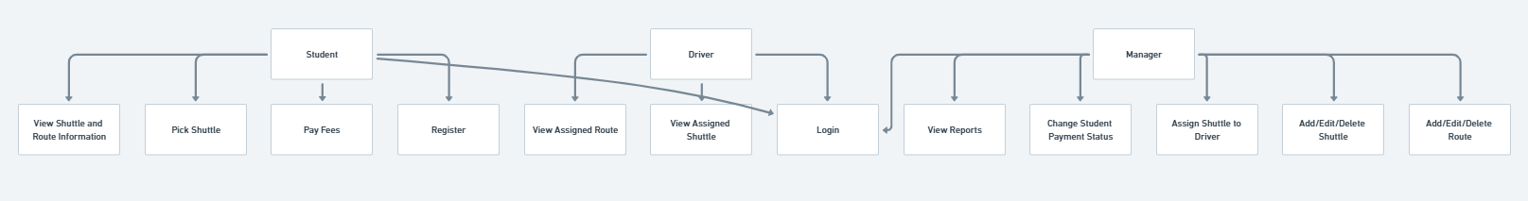

## Installation and User Manuals

**Requirements:**

Django==5.1.4

mysqlclient==2.2.0

Pillow==10.2.0

opencv-python==4.11.0

numpy==1.26.4

pytesseract==0.3.10

django-crispy-forms==2.1

django-allauth==0.58.2

**Install Dependencies**

**Ensure you have Python 3.12+ and MySQL installed.**

```bash

pip install -r requirements.txt

```

**Database Setup (MySQL)**

**Ensure MySQL is installed and running. Then, create the database and a user:**

```sql

CREATE DATABASE smart_transport;

CREATE USER 'smart_user'@'localhost' IDENTIFIED BY 'secure_password';

GRANT ALL PRIVILEGES ON smart_transport.* TO 'smart_user'@'localhost';

FLUSH PRIVILEGES;

```

**Configure settings.py**

**Update the database configuration in settings.py:**

```python

DATABASES = {

'default': {

'ENGINE': 'django.db.backends.mysql',

'NAME': 'smart_transport',

'USER': 'smart_user',

'PASSWORD': 'secure_password',

'HOST': 'localhost',

'PORT': '3306',

}

}

```

**Apply Migrations**

**Run the following commands to set up the database schema:**

```bash

python manage.py makemigrations

python manage.py migrate

```

**Create a Superuser (Admin)**

**To access the Django Admin Panel, create an admin user:**

```bash

python manage.py createsuperuser

```

Follow the prompts to set up a username and password.

**Run the Server**

**Start the Django development server:**

```bash

python manage.py runserver

```

The system will be available at <http://127.0.0.1:8000>.

### User Manual

* **Students**:

Register and log in

View Bus stops

Enter pick/drop information

View assigned routes

Make payments

* **Drivers**:

Register and Log in

view routes

Update trip status

View Stops

* **Managers**:

Access the web portal

Add bus stops

Manage Payments

Add vehicle

Add Routes

Assign Driver

## Tools and Technologies

* **Frontend**:  
  Django, Javascript, HTML and CSS
* **Backend**:

Python

* **Database**:

MySQL

## 

## Limitations and Potential Extensions

### Limitations:

* Data Accuracy: Inaccurate or outdated traffic and scheduling data may reduce the effectiveness of the system.
* Data Privacy Issues: Ensuring the system adheres to data protection regulations can be challenging.
* Limited Accessibility: Users without access to smart devices may face difficulties utilizing the system.

### Potential Extensions:

* Connecting Multiple Institutions: Expanding the system to support transport services between different universities.
* Smarter Predictions: Adding tools to predict future transport needs.
* Environmentally Friendly Features: Including options to track carbon emissions and suggest eco-friendly routes.
* Real-Time Notifications: Introducing notifications in the app to update users about schedule changes or delays.
* Live Driver Location Tracking: Allowing users to track the driver's location in real time for better planning.
* Online Payment Options: Implementing secure online payment methods for convenient and cashless transactions.

This report provides a detailed framework for implementing the Smart Transport Management System, focusing on creating an efficient and user-friendly experience for everyone involved.

**SMART TRANSPORT MANAGEMENT SYSTEM**

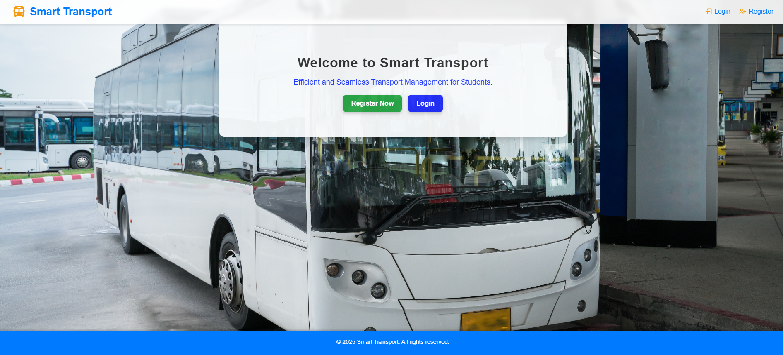

**REGISTRATION**

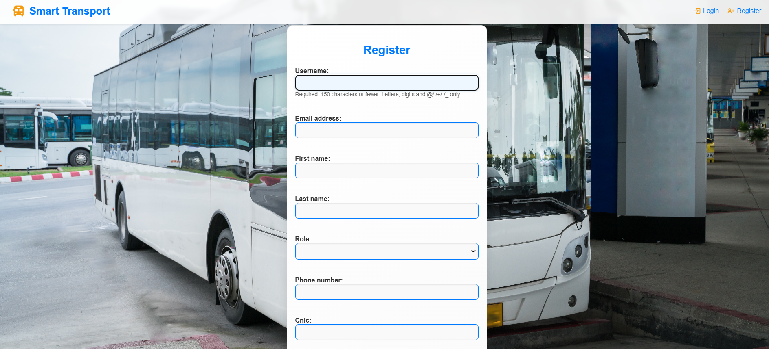

**LOGIN**

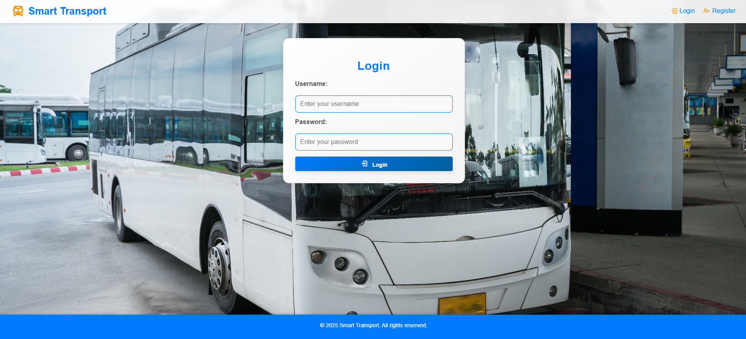

**USER DASHBOARD**

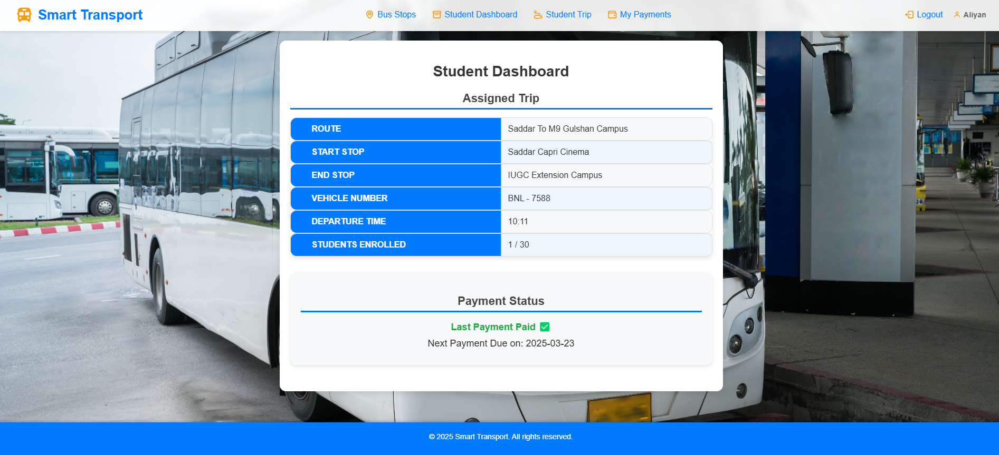

**BUS STOPS**

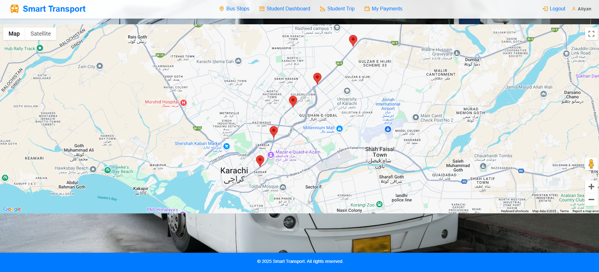

**STUDENT TRIP**

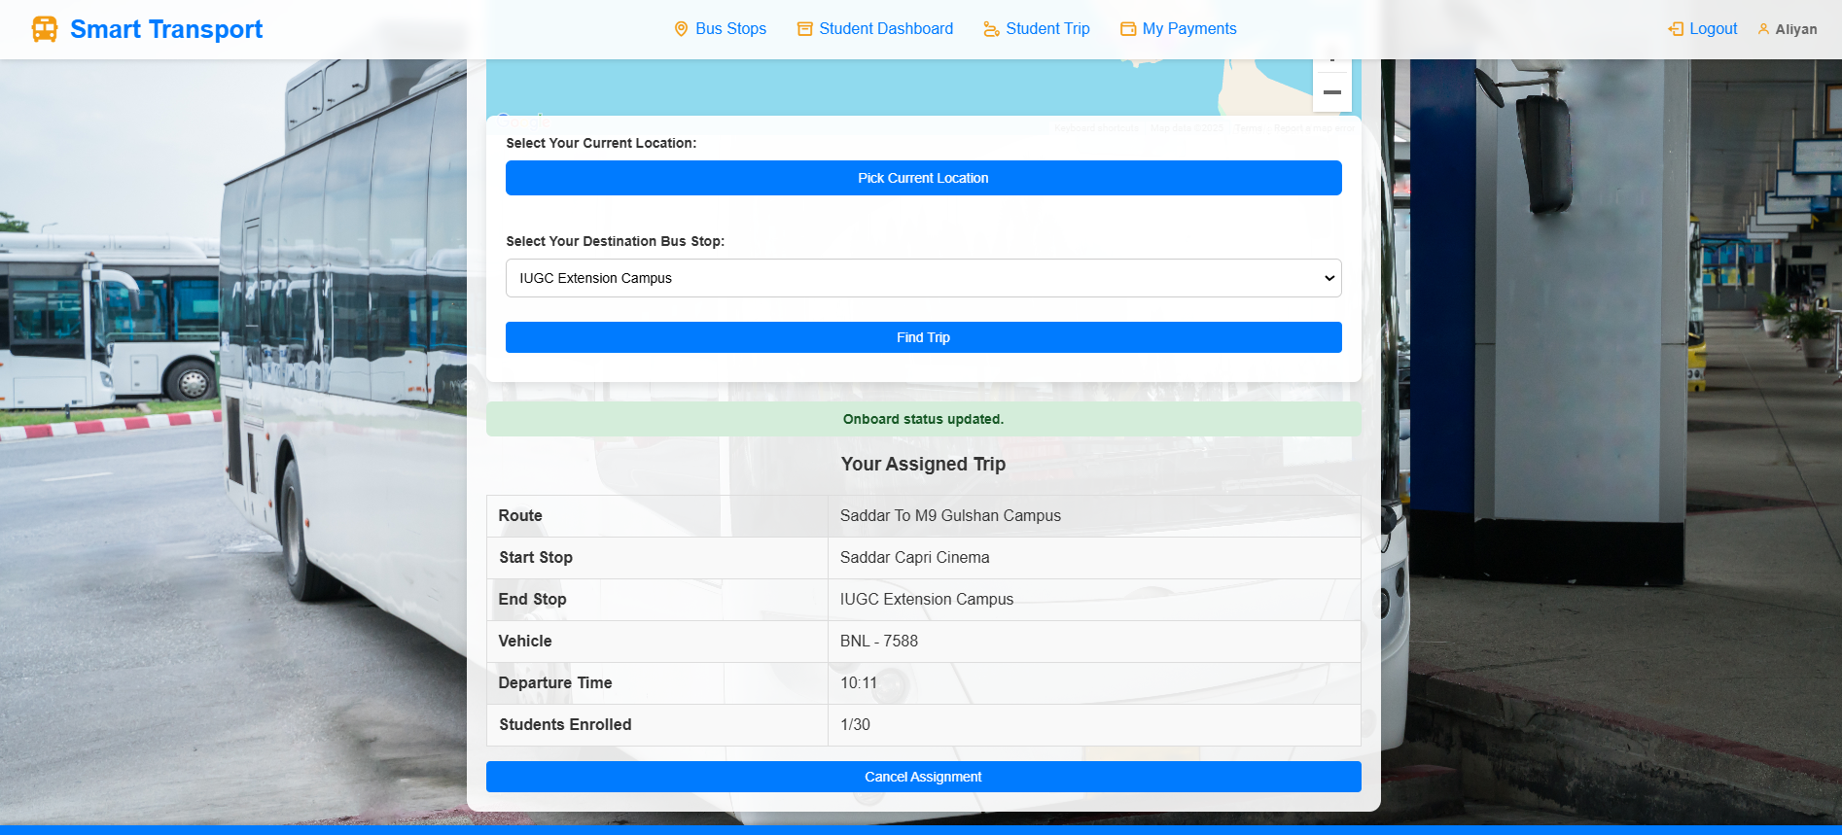

**PAYMENTS**

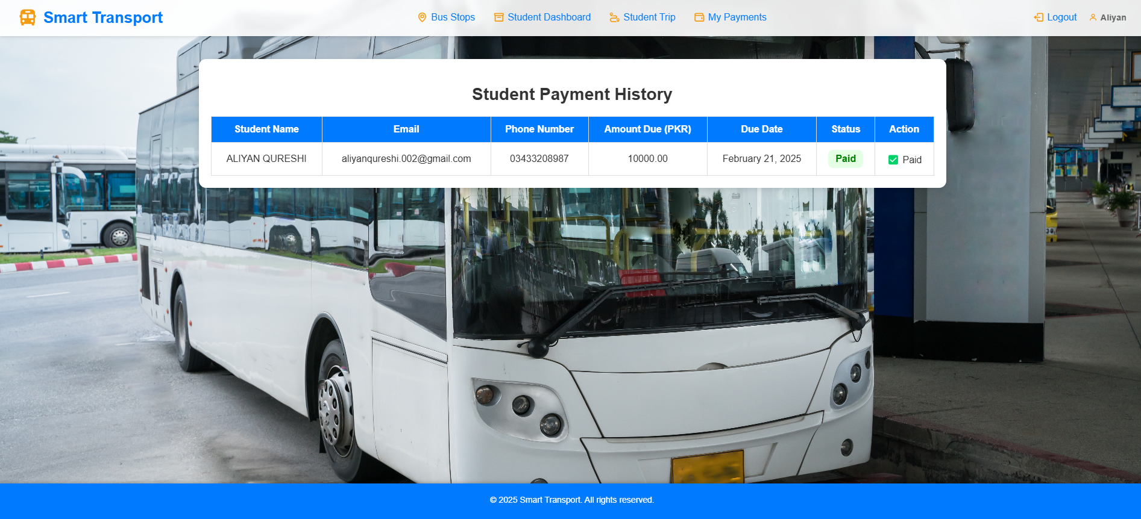

**DRIVER DASHBOARD**

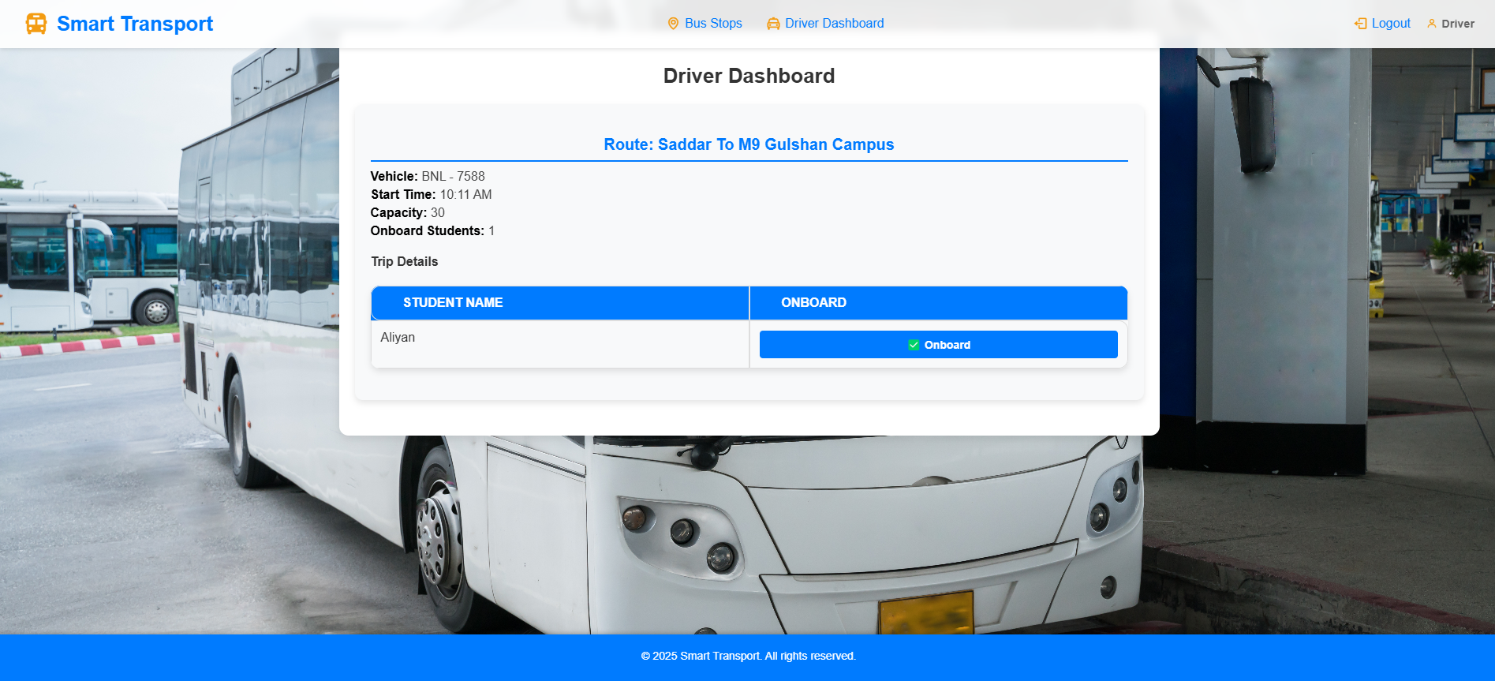

**BUS STOPS**

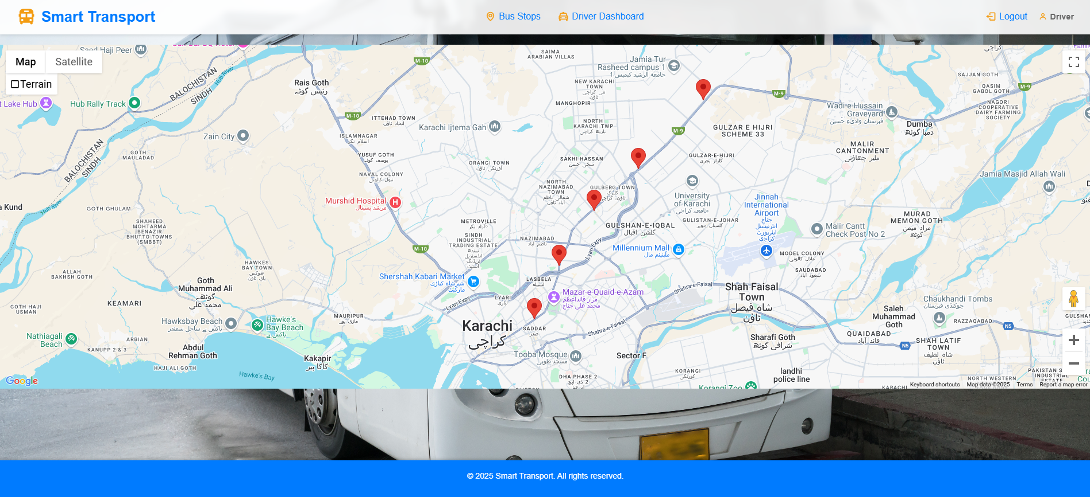

**MANAGER DASHBOARD**

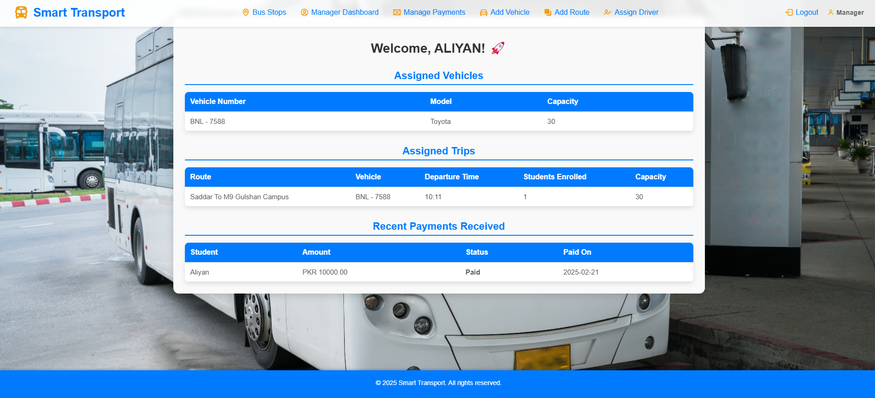

**ADD AND DELETE BUS STOPS**

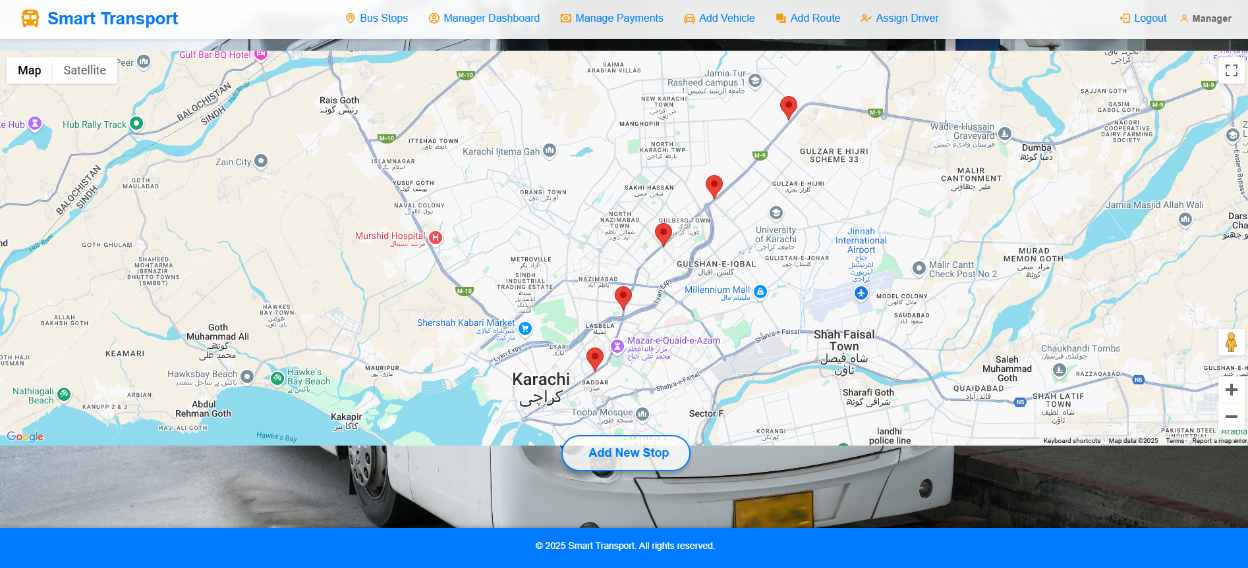

**MANAGE PAYMENTS**

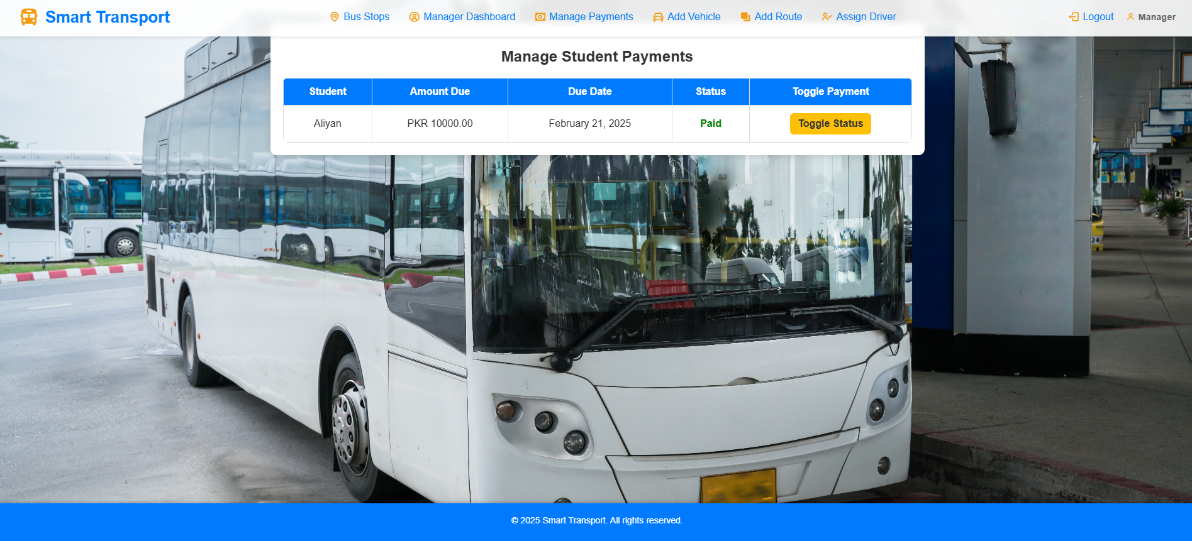

**ADD VEHICLE**

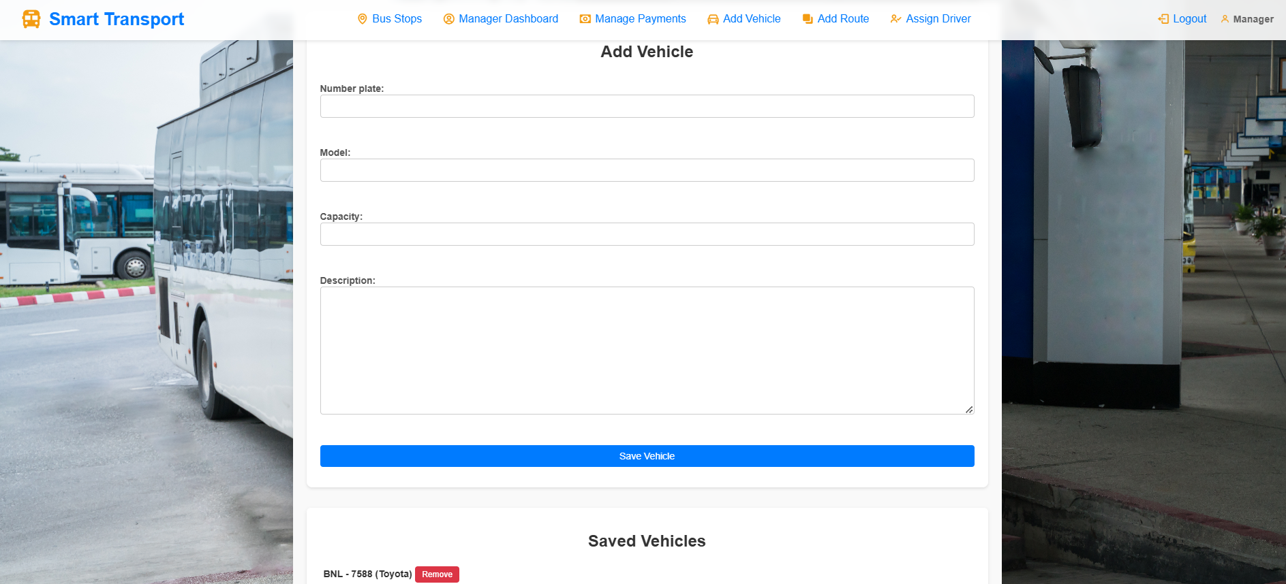

**ADD ROUTE**

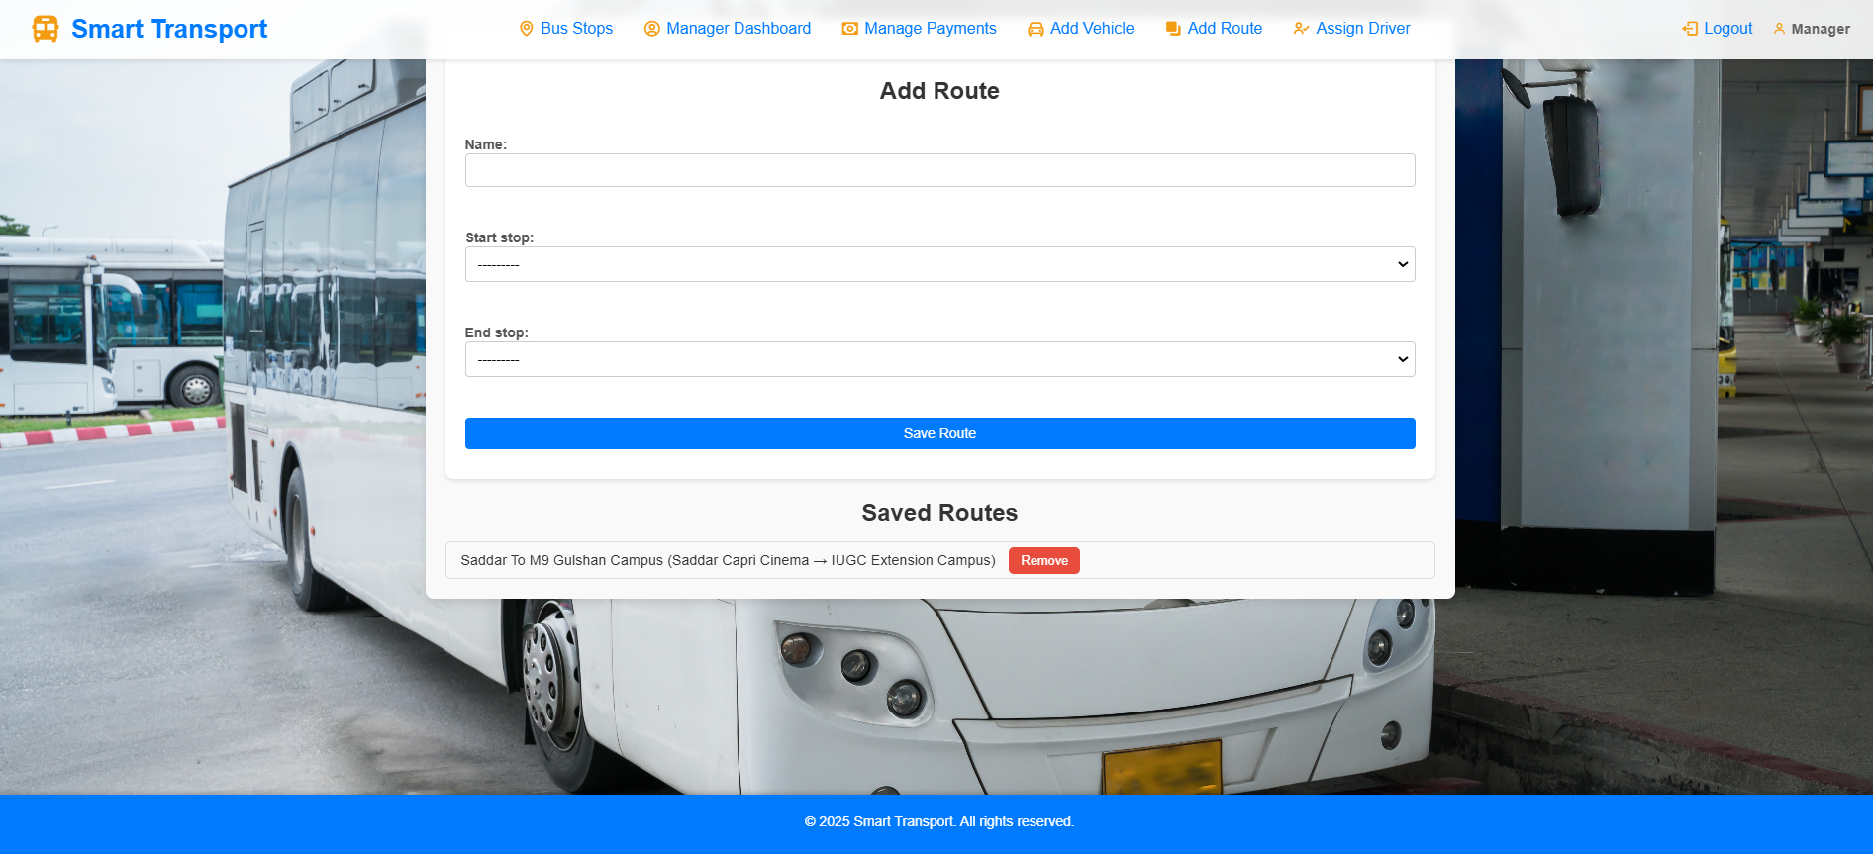

**ASSIGN DRIVERS**

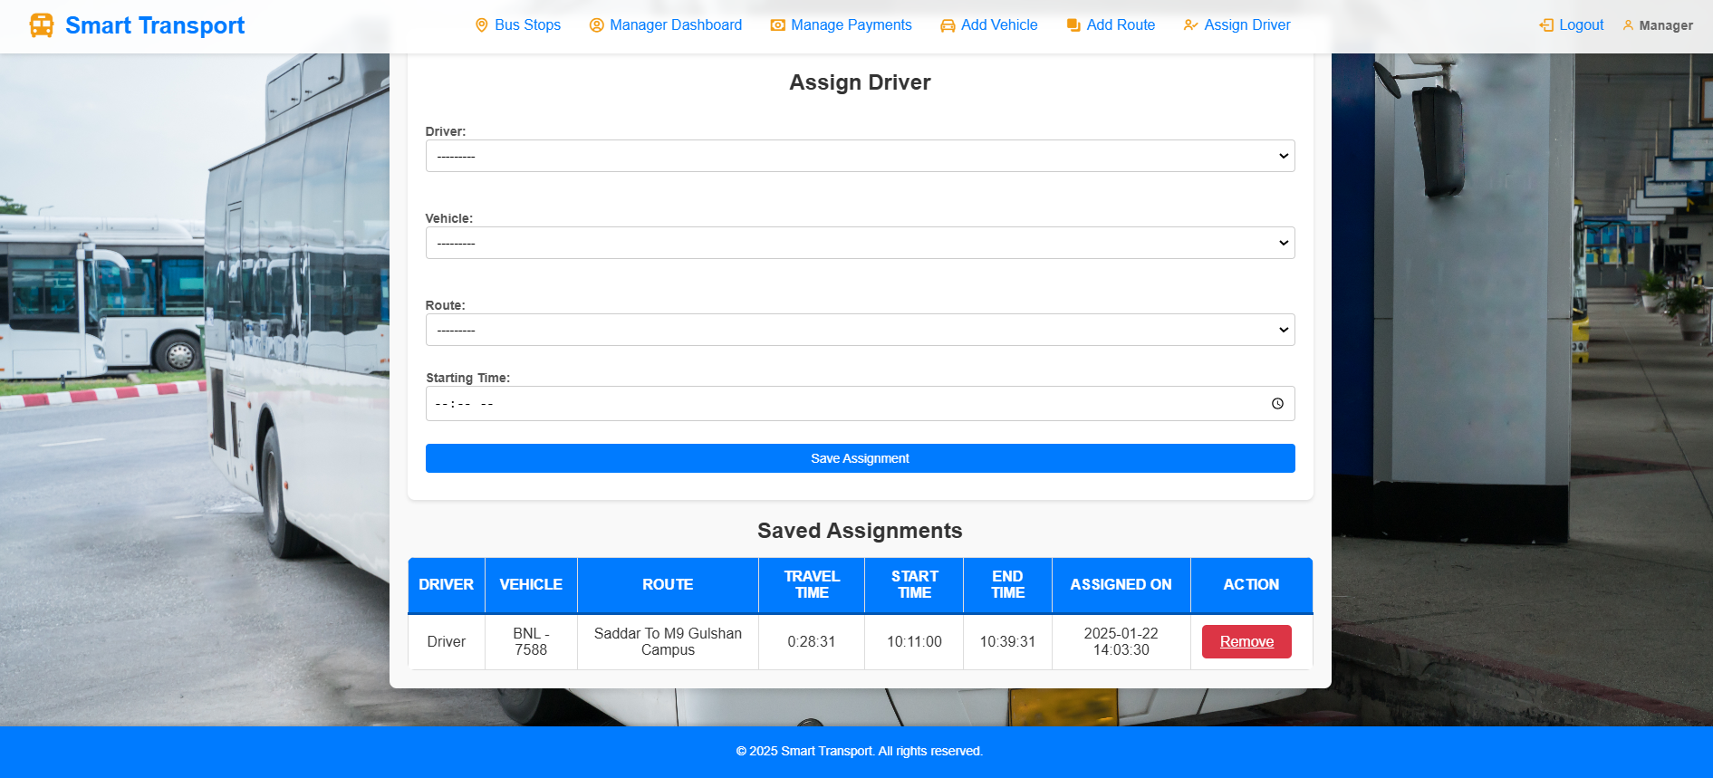

**YOUTUBE VIDEO LINK**

https://www.youtube.com/watch?v=ClIki3wUols